Барбарин

Лр 2. Настройка VLAN на коммутаторах

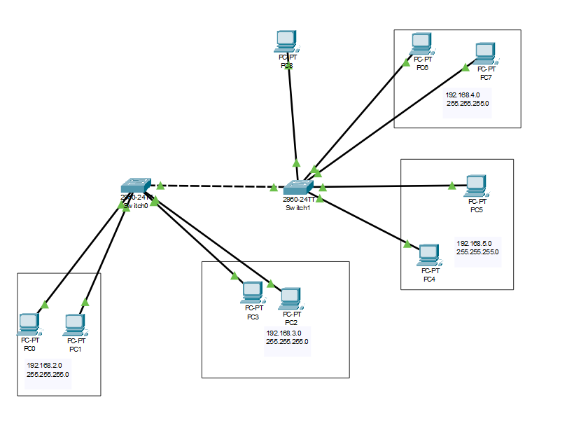

**Добавление влан в базу**

interface FastEthernet0/1

switchport access vlan 2

switchport mode access

!

interface FastEthernet0/2

switchport access vlan 2

switchport mode access

!

interface FastEthernet0/3

switchport access vlan 3

switchport mode access

!

interface FastEthernet0/4

switchport access vlan 3

switchport mode access

**Настройка физ портов**

interface FastEthernet0/1

switchport access vlan 2

switchport mode access

!

interface FastEthernet0/2

switchport access vlan 2

switchport mode access

!

interface FastEthernet0/3

switchport access vlan 3

switchport mode access

!

interface FastEthernet0/4

switchport access vlan 3

switchport mode access

**Настройка транк**

interface GigabitEthernet0/1

switchport trunk allowed vlan 2-5

switchport mode trunk